* Write a shell script that consists of a function that displays the number of files in the present working directory. Name this function “file_count” and call it in your script. If you use variable in your function, remember to make it a local variable.

Printing a name

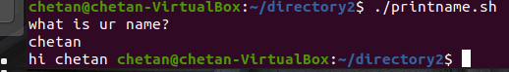

Pattern

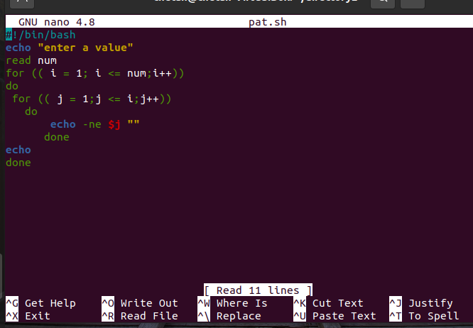

Start firefox application

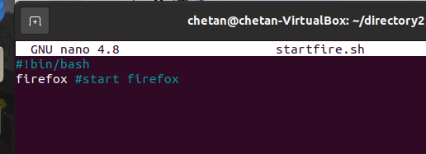



To add 2 floating point numbers

